THE ORIGINAL GOSPEL
AS WRITTEN IN THE STARS
INTRODUCTION: (Scriptures used are from the New King James Version)
Genesis 1:14 – Then God said, “Let there be lights in the firmament of the heavens to divide the day from the night; and let them be for signs and seasons, and for days and years;
God declares that the lights are for signs and seasons; which means they provide information about something we need to know or understand. Two main lights are the sun and the moon and these are for determining the seasons. The other lights are stars which are for signs. For this study we will focus on the topic of “signs”. The Hebrew word for signs is oth, from athah which means to come; therefore these signs that God placed in the heavens are of something or some One to come.
The study of the stars is the oldest of all human intellectual endeavors. Today we commonly refer to the 12 star signs of the zodiac, called the mazaroth in scripture, (Job 38). The word zodiac refers to the degrees or steps which mark the stages of the sun’s path through the heavens composing the twelve months of its annual cycle as seen from earth.
God’s purpose in naming and positioning the stars are to reveal His plan of redemption of mankind that was established before mankind was even placed on the earth; before the foundation of the world, (the social order of mankind). Knowledge of God’s plan was gained from the stars long before history began to be recorded; long before the scriptures were written.
Job had knowledge of God and His plan for a redeemer as he testified:
Job 19:25 – For I know that my Redeemer lives, And He shall stand at last on the earth;

This was approximately 2000 years before Jesus was born and shortly after the death of Noah. Written scripture dates back to Moses at approximately 1490 B.C. Thus for more than 2000 years prior to that written record knowledge of God’s plan was recorded in the heavenly signs, in the stars where man could not interfere with it and its message would remain consistently in veiw.
However, Satan has managed to pervert man’s understanding and knowledge gleaned from the stars by distorting the use of the signs and the meaning of them – now known as astrology. Satan’s goal is to get attention off of Christ, our creator, and on the world, creation, over which he is currently exercising his influence. Thus Satan led man to make an occult religion of the stars, worshipping them and getting guidance from them instead of from God. This began at the time of Nimrod and the building of the Tower of Babel in the plain of Shinar (Babylon).
Star study was known as astrology in ancient times; it only began to be called astronomy in the 18th century after astrology lost its scientific relevance giving place to the occult – horoscope, etc.
Let’s see what we can learn from the signs in the stars without having Satan’s distortions, perversions and influence. To accomplish this we will rely on the scriptures that God provided in the Bible.
We will see that the basic message of the gospel is revealed by the various constellations; in particular we have Genesis 3:15 clearly depicted in the heavens as we shall soon see.
Genesis 3:15 – And I will put enmity Between you and the woman, And between your seed and her Seed; He shall bruise your head, And you shall bruise His heel.”

Thus the twelve signs of the zodiac go all the way back to the foundation of the world. Jewish tradition, preserved and recorded by Josephus, assures us that this biblical astronomy was developed by Adam, Seth and Enoch, as being inspired of God.
God named the stars and placed them in specific groupings called constellations, Whether He named all the stars in the heavens remains to be seen, but we know that he named and positioned those stars that compose the twelve monthly signs because they serve His purpose in telling the story of redemption.
Psalm 147:4 – He counts the number of the stars; He calls them all by name.

Most of their ancient names have been lost through time; however over one hundred are preserved through the Arabic and Hebrew language and are used by astronomers today, even though the meaning of their names is unknown to them. We will see that in addition to each Zodiac sign there are “deacon” constellations that support the representation of each of the twelve primary constellations. Another significant observation will be the names of principle stars within these constellations and the meaning of their names which reinforces the theme of the each sign.
These groupings were first designed and named; then the picture, or portrayal, was drawn around them as God revealed this to ancient godly wise men. Thus knowledge and truth was recorded in the heavens:
Psalm 19:1-4 – The heavens declare the glory of God; And the firmament shows His handiwork. Day unto day utters speech, And night unto night reveals knowledge. There is no speech nor language Where their voice is not heard. Their line has gone out through all the earth, And their words to the end of the world.

What is it that the signs declare? What speech do they utter that is not heard? What knowledge do they provide those who study them? What glory do they tell of? The answer is found in Genesis 3:15 – the gospel message of the One to come (Jesus the Christ) to redeem fallen man and to defeat the enemy, that serpent, the devil.
In God’s wisdom, He knew that only a portion of the constellations were visible from any one place on earth. Therefore He provided multiple heavenly signs that display the complete gospel message that can be viewed from any hemisphere on earth; North, South, East or West. The signs are thus divided into hemispheric groupings so that all over the world one can see the same message even though revealed by different signs. There are three groupings, each having four primary signs with their “deacon” constellations which add more detail to the meaning of each sign. (See attached illustration which sections the 12 signs into these groupings.)
- THE UNIVERSAL REVELATION OF GOD TO THE WORLD

- God makes Himself known by His creative acts – there is no evolution.

- Romans 1:16 – the gospel is for everyone who chooses to accept it.
- Romans 1:17 – it is revealed by faith, not works and can’t be earned.
- Romans 1:18 – woe to those who choose the path of unrighteousness by
failing to accept God’s provision for them.
- Romans 1:19 – nature reveals God by His order and wisdom of what He
has made.
- Romans 1:20 – Thus mankind is without excuse to not recognize Him and
His plan and true righteousness.

- God’s plan is plainly shown and made visible – Psalm 19:1-4.

- Psalm 19:1 – Look up to see His plan.
- Psalm 19:2 – Knowledge is gained at night by seeing the signs in the stars.
- Psalm 19:3 – Everywhere on earth is covered – each hemisphere.
- Psalm 19:4 – This knowledge remains to the end of the world (age).’
- God’s method and purpose.

- Psalm 147:4 – Scientists estimate there are 40 sextillion stars.
  - God has a specific name for each star, at least with respect to earth.
- Genesis 1:14 – God positioned them for signs to show us something.
  - Each sign is a constellation named by Adam, Seth or Enoch.
- Constellations are named in the Bible.
  - Job 9:9 – Arcturus, Orion and Pleiades.
  - Job 38:31-32 – Arcturus and its sons; also Mazzaroth.
- Mazzaroth is the Biblical term for the 12 signs of the zodiac.
aa. Ancients used these for times and seasons.
  - Amos 5:8 – The seven stars of Pleiades; Orion.
Note: Job 19:25 shows that Job exhibited great knowledge of God before that of Moses or the prophets wrote and before scripture was recorded. Where did he get that knowledge? From the stars!
- The constellations tell the complete story of Christ, the gospel of redemption and the defeat of Satan.
- Thus we see Satan’s attempt to obscure the true gospel message resulting in astrology and horoscopes.
- Satan can only work with what God has created.
- Satan is the master deceiver and father of liars who perverts our understanding of God’s creation.
- Satan is the source of the teaching of evolution also to deny
Man was made in the image of God.
Note: Ancient names of the stars were in Arabic and Hebrew. It is these names and their meaning that has been forgotten and which have been renamed by man in more modern times under Satan’s influence to misuse and distort the meaning and message they hold. In this study we will go back to the ancient names which are still known and see that the entire gospel message is written in the stars and revealed by their names and the illustration of the signs. The same message is portrayed in every quadrant of the earth by the various constellations. It is also worthy to note that these signs and the orientation of these stars is seen only by the earth and no other location in the universe reveals this message.
Modern astronomers do not study the stars as the ancient astronomers did. In days of old star study was to gain knowledge of the creator – GOD. Star study today is to gain knowledge of creation having taken the creator out of their search. They do this as modern science considers man to be supreme, or possibly under another life form they call extraterrestrial. Thus their study of the stars is to find other life or the source of life because they reject God as that source. Why do they reject God as the source of life, because He is beyond their understanding and comprehension. This is amazing since the stars reveal Him and His plan for mankind on earth. Such is the result of the quest for knowledge while exempting God from their knowledge.
Romans 1:18-23 - For the wrath of God is revealed from heaven against all ungodliness and unrighteousness of men, who suppress the truth in unrighteousness, because what may be known of God is manifest in them, for God has shown it to them. For since the creation of the world His invisible attributes are clearly seen, being understood by the things that are made, even His eternal power and Godhead, so that they are without excuse, because, although they knew God, they did not glorify Him as God, nor were thankful, but became futile in their thoughts, and their foolish hearts were darkened. Professing to be wise, they became fools, and changed the glory of the incorruptible God into an image made like corruptible man—and birds and four-footed animals and creeping things.
The ancient wise men or maggi of Babylon studied the stars and understood the significance of the signs they represented. This explains the wise men coming to find “He who was born King of the Jews” (Matthew 2:2 ). These wise men were the descendants of Daniel and his Hebrew friends that were made magi by Nebuchadnezzar after their captivity and who did not return to their homeland after the 70 year captivity, ( as recorded in the Book of Daniel 1:17-21).
This is also why you do not read about the wise men in Luke’s account of the Birth of Jesus and the nativity; because they were not there as our man-made traditions indicate.

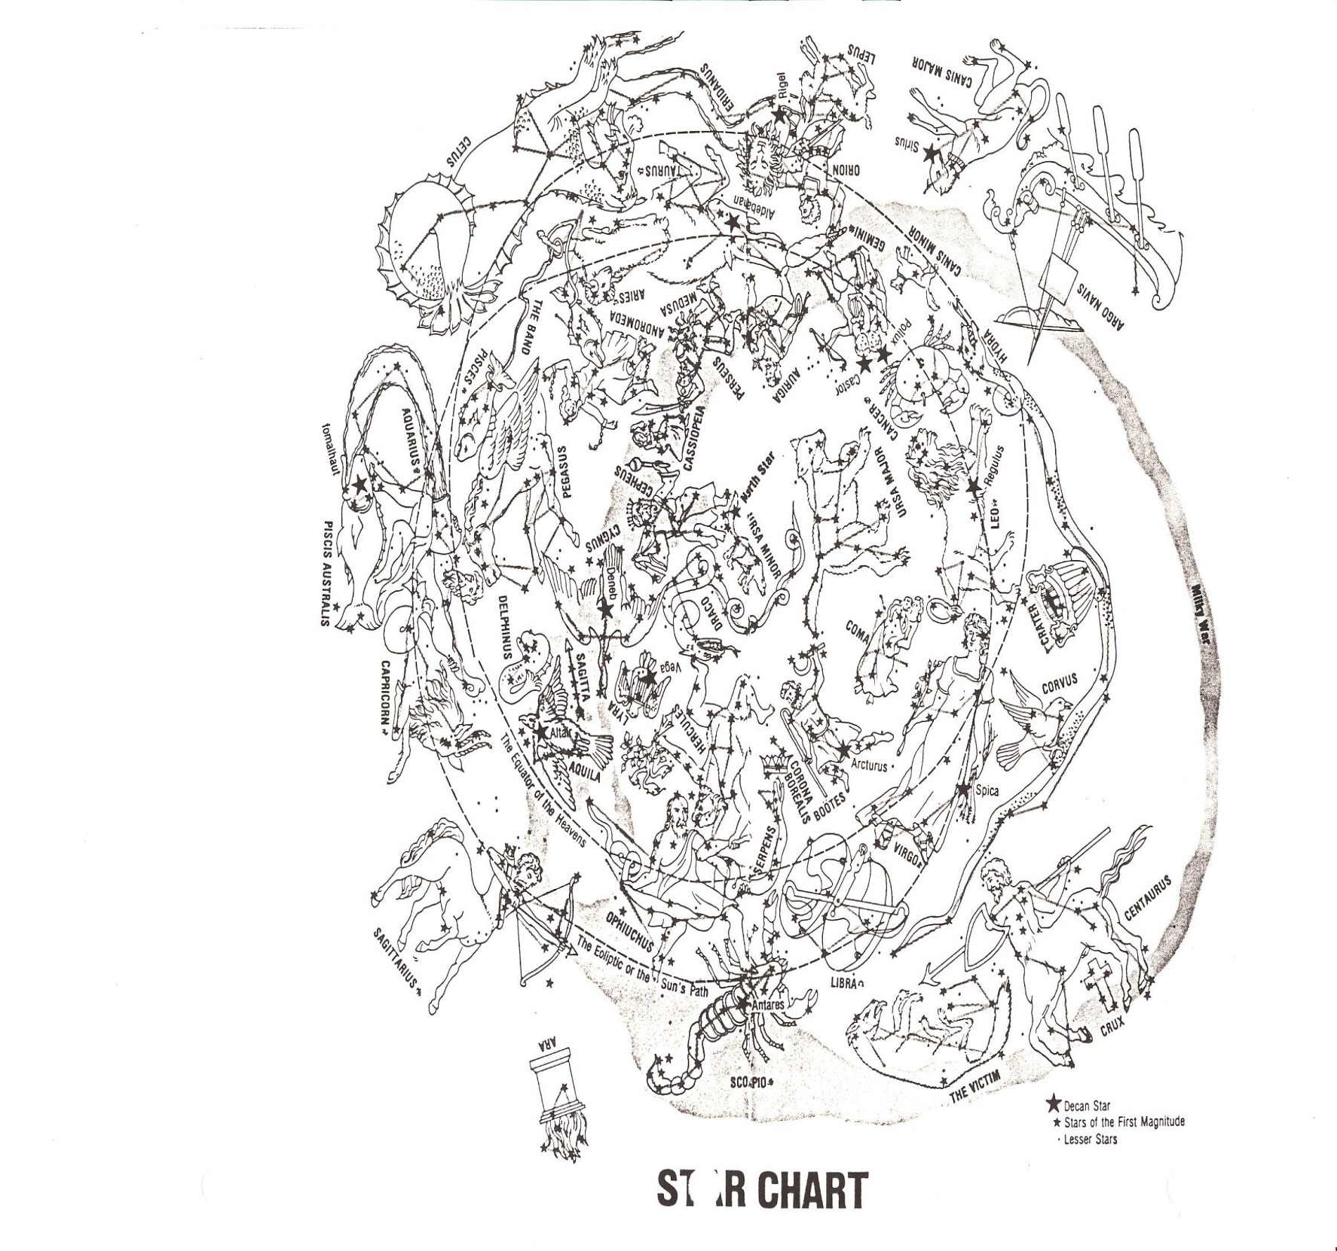
The twelve signs of the Zodiac are divided into three groups or three books. Each book contains four chapters with each chapter named after the principle constellation.

The first book represents The Redeemer and His first coming. The second book represents The Redeemed and what the Redeemer accomplished. The third book represents the Redeemer’s second coming in triumph over the enemy. 